LCC Meeting Minutes
Coalition Name and County | Hendricks County Health Partnership
Meeting Date and Time | December 14th, 2022 8:30-9:30 a.m.
Meeting Location | In-Person at MADE@Plainfield
Minutes Drafted Date | December 14th, 2022

Attendees
18 Attendees
Ashley Moeller Mill Creek Schools
Chase Cotten The Willow Center / Partnership Co-Leader
Joshua Faith HC Sheriff’s Office - SRO at Cascade HS
Maci Valdez DMHA
Michael Aviah Hendricks County Health Department / Partnership Co-Leader
Rosie Fakes At Large - Formerly Cascade HS
Jessica Strong Hamilton Center
Maria Hennigan Hamilton Center
Moriah Veach Care to Change
Staci Hovermale Plainfield Youth Assistance Program
Rob Hovermale MercyBase Church
Nate Hawk Avon Police Department
Ray Kotarski Brownsburg Police Department
Alex Goodnight Congressman Baird’s Office
Diane Hubbard Congressman Baird’s Office
Eric Hessel Hendricks County Community Foundation
Sharon Melendez Avon Public Library
Christina Anderson New Strength Counseling / HC Phoenix Collaborative

Meeting Notes (Old/New Business, Decisions, Agendas)
- Welcome (Chase)

- Review of updated Collaborative Efforts Flow Chart (Chase)

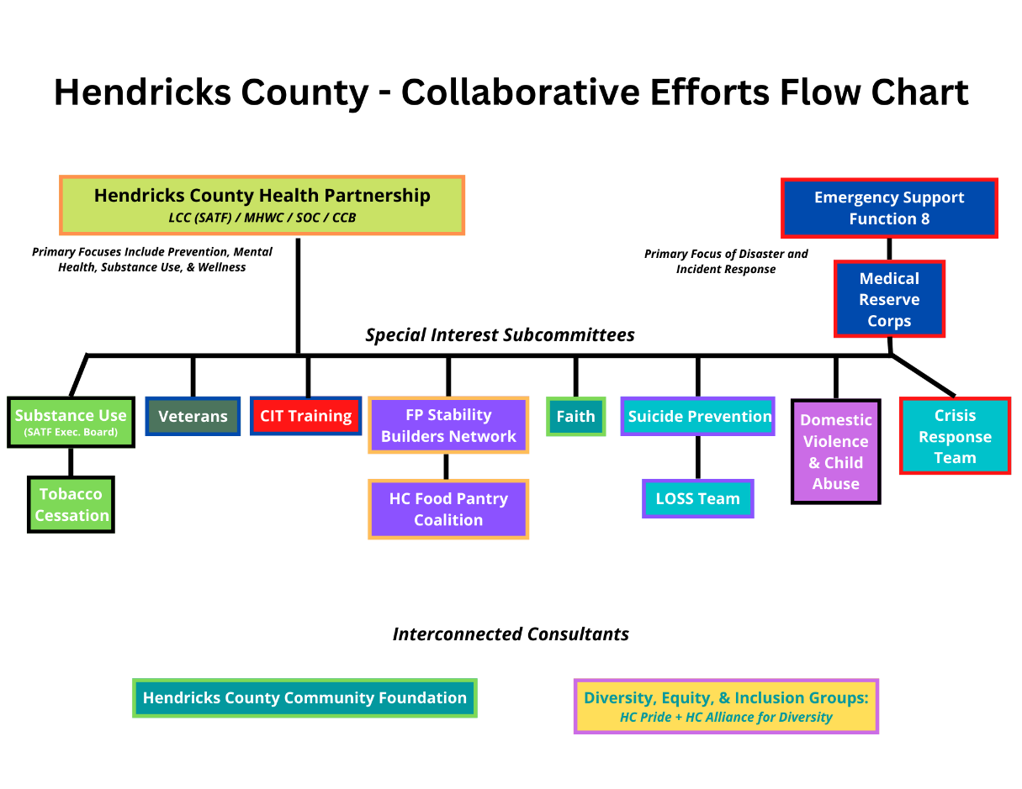

- Hendricks County Behavioral Health Strategic Plan: Chase walked the group through the background, process, and 9 primary “Strategies” that the behavioral health survey committee has prepared for the Partnership to work toward accomplishing over the next 5-7 years.
  - The final draft of the Strategic Plan will be emailed out to the Partnership early next week for review and reference.

- Next Meeting: January 11th, 8:30am-10:00am - Quarterly Professional Development Workshop – VIRTUAL
- Applications are OPEN for the upcoming SATF-LCC Grant Cycle. You can find the application form on the Partnership website here: https://www.hendrickshealthpartnership.org/partnership-member-documents.html
  - Applications are due to Christa Detzel by January 11th, 2022 – crdetzel@sbcglobal.net

- 2023 Meetings Calendar:
  - January 11th, 2023 – 8:30am-10:00am – Quarterly Professional Development Workshop – VIRTUAL
  - February 8th, 2023 – 8:30am-9:30am – Regular Meeting (+ LCC Grant Month) – HYBRID
  - March 8th, 2023 – 8:30am-9:30am – Regular Meeting – VIRTUAL
  - April 12th, 2023 – 8:30am-10:00am – Quarterly Professional Development Workshop – VIRTUAL
  - May 10th, 2023 – 8:30am-9:30am – Regular Meeting – VIRTUAL
  - June 14th, 2023 -- 8:30am-9:30am – Regular Meeting – VIRTUAL
  - July 12th, 2023 – 8:30am-10:00am – Quarterly Professional Development Workshop – VIRTUAL
  - August 9th, 2023 – 8:30am-9:30am – Regular Meeting – VIRTUAL
  - September 13th, 2023 – 8:30am – Regular Meeting – VIRTUAL
  - October 4th, 2023 – 8:30am-9:30am – Regular Meeting (+LCC Grant Month) – HYBRID
  - November 8th, 2023 – 8:30am-9:30am – End of Year Celebration Breakfast – IN-PERSON
  - December 13th, 2023 – 8:30am-9:30am – 2024 Planning & Strategy – VIRTUAL

SATF LCC Financial Report/Budget Summary
Current balance of account (as of 10/31/22): $146,082
Expenses for October: $19,647 Deposits for October: $9258
Budget for 2022 is $32,200 per category (128,800 total)

Balances for Categories:
Discretionary funds $5000
Education/Prevention $7584
Treatment/Intervention $0
Law Enforcement/Criminal Justice $7195

SATF Executive Board / Substance Use Special Interest Committee

Diane Buxton, Chase Cotten, Jeremy Watson, Christina Anderson, Rosie Fakes, Betsy Schuler, Chuck Parsons, Christa Detzel. No follow up discussion today – no actions taken.

Adjourned: 9:20am.
NEXT MEETING:
January 11th, 8:30am-10:00am - Quarterly Professional Development Workshop – VIRTUAL

